**Explore Weather Trends Udacity (Global – Local city Temperature)**

1. **SQL Queries**

SQL Query For Global data: **select * from global_data;**

SQL Query For Jaipur City (Local) data: **select * from city_data where city = 'Jaipur';**

SQL Query For Ahmadabad City (Local) data: **select * from city_data where city = ‘Ahmadabad’;**

SQL Query For Berlin City (Local) data: **select * from city_data where city = ’Berlin’;**

SQL Query For Houston City (Local) data: **select * from city_data where city = ‘Houston’;**

**2.Manipulate data with Python**

I have used Python for manipulation of data and calculation of moving average with rolling/moving window of 10. To do this task in python I have used pandas and matplotlib library. Pandas used for manipulation of data and calculation of moving average and Matplotlib is used for visualization of data in the form of graph/chart.

1. **Data visualization**

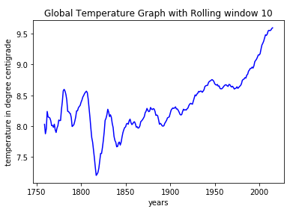

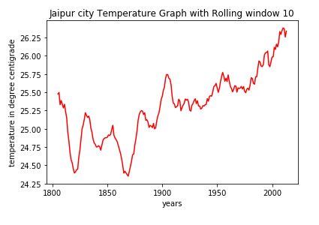

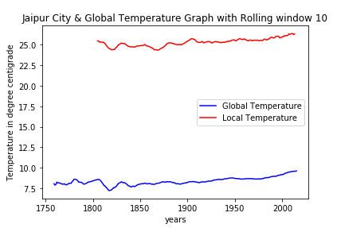

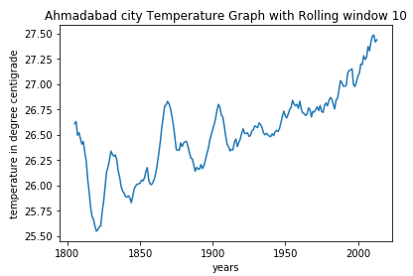

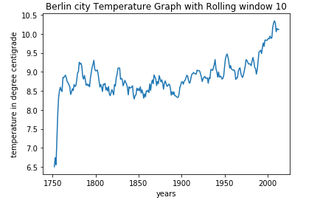

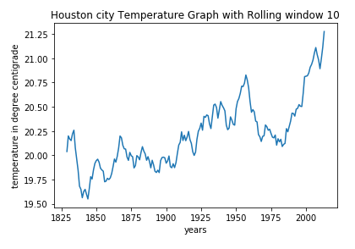

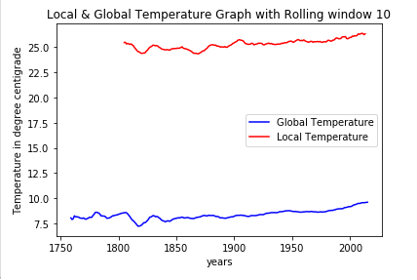

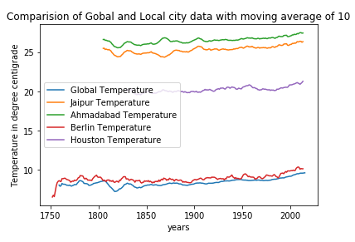

**4. Observations**

**Observation 1 -** My city is hotter on average compare to the global averagetemperature**.** The difference between both temperatures is consistent over time on average.

**Observation 2 –** Change in temperature of Jaipur city over time is not consistent in comparison of global temperature. In 1820 the temperature is consistent the temperature is decreased but in 1870 the temperature of Jaipur city is decreased by around 1.5 degree centigrade but the global temperature in not decreased by considerable amount.

**Observation 3 –** The overall trends look like the temperature is increasing till 1950. After 1950 the temperature is exponentially increased overtime.The getting hotter and hotter. The trend is been consistent over the last few hundred years.

**Observation 4 –** Both the graphs are having a relationship. Which can be stated as - The global temperature is directly proportional to Jaipur Temperature. Which also state that global temperature is nothing be the average temperature of all the city around the world. If the Local city temperature is increased that it will affect global temperature.  
  
Correlation Matrix Also verifies these Results:  
  
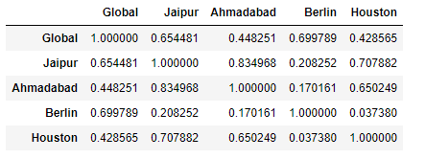

**Observation 5-** The graph shows the after 1950 the global as well as local temperature which is relevant since the motorbikes and all the instruments are build after 1950 and people around the global are adopted on large scale.  
  
  
**NOTE: For more info please refer the jupyter notebook file “Temperature Trends.ipynb”.**